**PAGE 404**

**What is a page 404?**

**When does it occur?**

**Why is it interesting for us?**

**Key words: marketing, culture, branding**

1. **Reference to pop culture:**

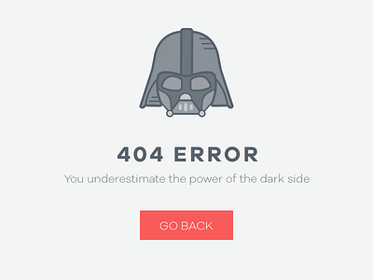

What is the error page referring to?

Is it smart? Is it funny?

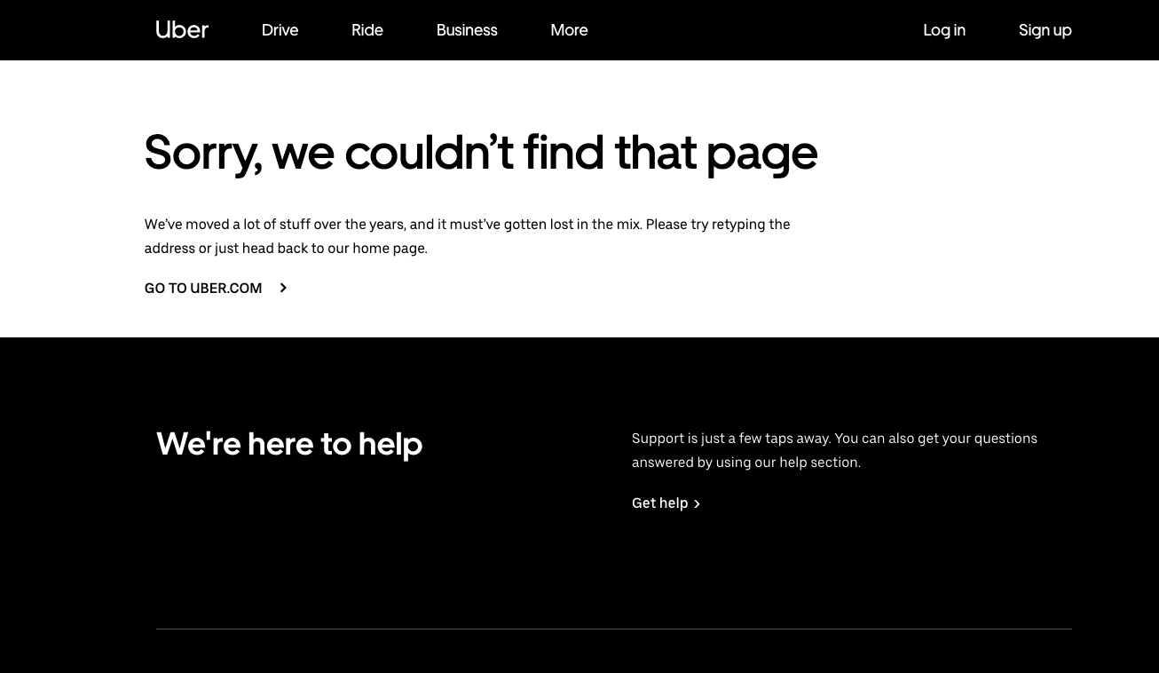

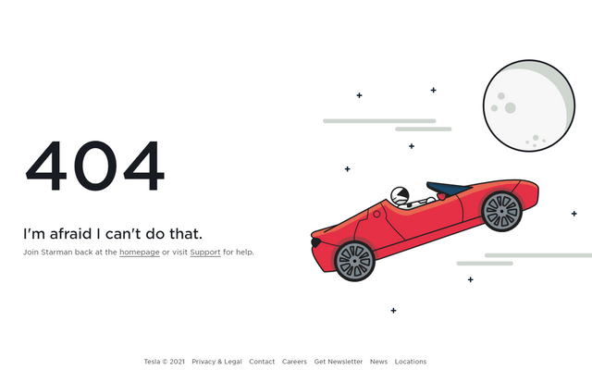

**YOUR TASK**:

Create your page 404. Choose a brand or a mass media phenomenon (Marvel, movies, Nike, Apple…) and create a smart slogan that you will put on your Page.

I want you to include some of the following expressions into the language of your Page 404 slogan:

Oh, no!

Ooops!

Sorry!

Go back!

Yikes!

Shoot!

**Say what mass culture phenomena the page is making reference to, and explain why it is funny and/or smart.**